But what if the same task is assigned at 4:00pm? Using simple arithmetic, we might say that the task is due to be complete at 7:00pm. However this does not take into account the business hours of the company. If the office hours are 8:00am to 5:00pm then it would be wrong to ask the staff to complete the task by 7:00pm. To solve this puzzle, we look at an additional BPM concept called "Time Schedule". The Time Schedule defines the working hours of a business. When the Time Schedule is applied to the due date calculation of a task, that due date is no longer a simple arithmetic calculation.
但是如果相同的任务被分配到下午四时? 使用简单的算法,我们可以说,任务将在晚上七时完成。 然而这并不考虑公司的工作时间， 如果工作时间是上午8:00到下午5:00,那么要求员工在下午七点完成任务将是错误的。为了解决这个难题,我们看一个额外的BPM概念叫做“时间计划表”。时间计划表定义了业务的工作时间。当时间计划表应用于到期日的计算任务时,到期日不再是一个简单的算术计算。

For example, if the Time Schedule declares that our working hours are 8:00am to 5:00pm and a three hour task is started at 4:00pm, we would calculate a due date of 10:00am the next day.
例如，如果时间计划表声明我们的工作时间是从8:00am 到5:00pm，有个三小时的任务是从4:00pm开始，我们计算出来的过期时间应该是第二天上午的10:00。

Not only does the Time Schedule contain working hours, but it also describes the working days.
For example, a task started at 4:00pm on a Friday may not be due until 10:00am on the following
Monday.
See also:
• Data Type – TWTimeSchedule
时间计划表不仅仅包含工作时间，还可以描述工作日。例如，如果任务是在星期五的4:00pm开始，它可能到下个周一才会过期。
另见：
- 数据类型 - TWTimeSchedule

Generating Reports
We can generate reports (documentation) based on the content of our Process Applications. From
within Process Center we can select a Process Application and navigate to its Snapshots settings.
Clicking on the name of the Snapshot takes us to the reports section:

生成报告
我们可以基于PA的内容来生成报告。在Process Center里，我们选中一个PA然后导航到快照的设置页面。点击快照的名称将会进入报告部分：
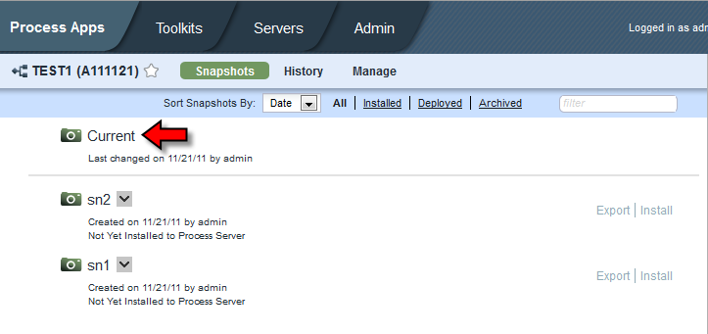

From there we get to see a summary of the major sections of our Process Application:
从那里我们可以看到PA的主要部分的一个概要
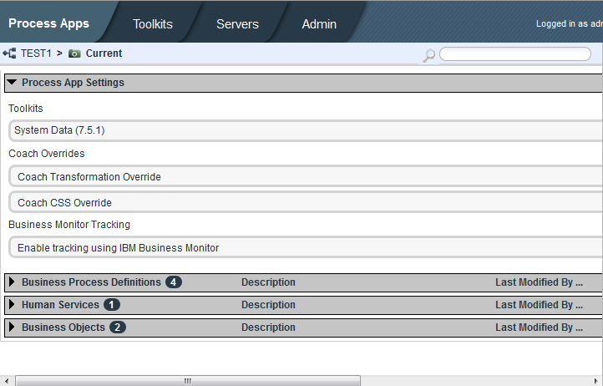
For each of these we can drill down and see more details and, in certain cases, generate reports for printing or transforming into PDFs for recording.
对于每一个部分，我们都能够展开并看到更多的细节，一定情况下，可以生成打印报告或者转化为PDF以备记录。

BPD and BPMN
Originally called the Business Process Modeling Notation, the latest BPMN 2.0 specification has renamed itself to the Business Process Model and Notation. The purpose of this section is to contrast what is contained in the BPMN specification against what is found in the BPD diagrams of the IBPM product. We will not describe BPMN in depth as that would be the subject of its own book (the spec itself is 550 pages) and the reader is referred to one of the many references including the BPMN specification itself.
See also:
• BPMN Specification page

业务流程定义和业务流程建模符号
最早被称作业务流程建模符号，在最新的BPMN 2.0规范已经被重新命名为业务流程建模和符号。这部分的目的就是要对比一下我们所见到的IBPM产品中的BPM图形与BPMN规范的不同之处。
Concept of a Token
As a process runs from its Start to its End, the process executes a sequence of activities. The sequence of executed activities is governed by the Sequence Flow (lines) between the activities.Assuming that there are no parallel branches in the process, at any one time, a single Activity is being performed. To aid in understanding this idea and to be able to discuss in more depth, we introduce the logical concept known as the token. A token is an imaginary item and is not formally part of either the BPMN specification or the IBPM product. A token can be considered to be at exactly one activity in a process and the activity which has the token is available to run or is actually running. When an Activity completes, the token can be thought of as moving along an outgoing Sequence Flow to the next Activity. To help your understanding, you can think of the token as moving instantly from one activity to the next … another way of saying this is that it spend no time traversing the Sequence Flow itself.

令牌的概念
作为一个流程从开始到结束,流程会执行一系列的活动。活动执行的顺序是由各个活动之间的序列流(不同行)来管理的. 假定在流过程中没有并行分支,在某一个时刻,会有某单个活动正在进行。为了帮助理解这个想法,让我们能够更深入地讨论,我们引入了令牌这个逻辑概念。 令牌是一个假想的东西,没有成为BPMN规范或IBPM产品的正式一部分。令牌可以被认为是在一个流程中的具体活动可以有令牌使得它能运行或正在运行。当一个活动结束,令牌可以被认为是沿着一个序列流到转移到下一个活动。为了帮助你的理解,你可以想象令牌能够立即从一个活动转移到下一个…另一种说法是,它不花费时间遍历序列流本身。

A dictionary definition of a token is very appropriate:
1. something serving to represent or indicate some fact, event, feeling, etc.; sign: Black is a token of mourning.
See also:
• Token Management
• Moving a token within a process using REST
有个很适合的令牌的字典定义:
1.用来代表或说明一些事实,事件,感觉,等；标志:黑色表示哀悼。
另见:
•令牌管理
•使用REST API在流程中移动令牌
Deviations from BPMN
IBPM supports much of the BPMN story but there are some deviations in the implementation of the IBM product that are worthy of note.
Parallel Starts
Here we have a BPMN fragment that shows that when a process starts, in BPMN it will execute two activities in parallel.

与BPMN的偏差
IBPM支持BPMN的案例,但值得注意也有一些偏差出现在IBM产品的实现中。

并行的开始
在这里我们有一个BPMN片段显示,当一个流程启动时,在BPMN会并行执行两个活动。
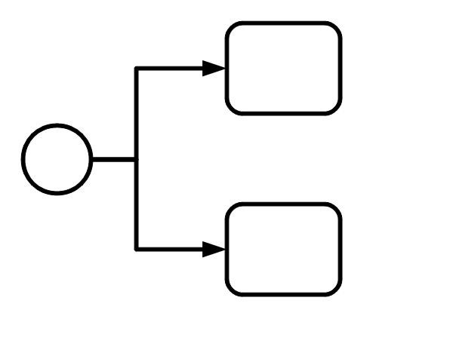
If we try and code this in IBPM, it won't work. Only one path or the other will be taken but not both. To achieve the parallelism we desire, we need to add an explicit Parallel Gateway.
如果我们试着运行这样IBPM代码,它不会工作。只有一个路径或另一个而不会是两个被执行。想要实现我们期望的并行性,我们需要添加一个显式并行网关。
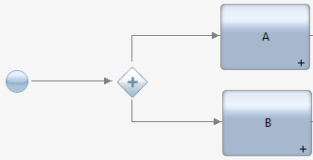
Other than stylistic differences, the two are semantically identical.
除了风格上的差异，二者具有相同的语义。
Looping
BPMN provides the concept of a loop which looks like an activity. If the activity is expanded, we can see the contained activities which are to be executed repeatedly. One common way of using looping is to repeat an activity until something has been "satisfied". Consider a loop that periodically checks that an oven has reached a specific temperature. If it has, we end the loop if not, we check again some time later. This is a loop concept that in Java might have been called a while-do (or do-while) loop. A predicate (boolean valued expression) determines when the loop is to terminate.

循环
BPMN提供了一个循环的概念,看起来就像一个活动。如果活动扩大,我们可以看到所包含的活动会被重复执行。使用循环的一个常用方法是重复的活动,直到被“满足”。想象会定期检查烤箱是否到达一个特定的温度一个循环，如果是,我们结束循环，如果没有,我们晚些时间再次检查。这是一个在Java中可能被称为while-do(或do-while)循环的概念。一个谓词(布尔值表达式)决定何时终止循环。

Another (but distinct) looping construct in BPMN is the for-each loop. This is a loop which is executed some finite number of times with the activities contained within executed sequentially or in parallel. This looping construct has a distinct appearance from the other loop.
在BPMN的另一个(但是不同)循环的构造是 for - each。这是一个执行一些包含顺序或并行执行的有限次数的循环,这个循环构造和其他循环外观有所区别。

IBPM provides a looping construct that is based on the for-each looping style. However, the visual representation of the IBPM activity is that of the while-do loop style. IBPM does not provide a separate while-do activity style.
IBPM提供了一个基于for - each循环风格的循环结构。然而,IBPM活动的可视化表示是while-do循环的风格。IBPM不提供一个单独的while-do活动风格。

XPDL Support
XPDL is an Open Standard describing the exchange of BPMN diagrams as XML documents. IBPM does not support either import or export of XPDL format documents.

XPDL的支持
XPDL是一个用于描述BPMN图元交换的开放标准的XML文档。IBPM不支持导入或导出的XPDL文件格式。

Boundary exposes Start Events
A process diagram can have more than one Start Event defined within it if the Start Events are placed on the boundary of the diagram. This allows a single Process to be started at multiple potential start places by its caller.
IBPM does not support this pattern.

公开边界启动事件
如果启动事件被放在图的边界，一个流程图就可以定义多个启动事件，这就允许通过调用多个潜在启动事件来开始一个流程。
IBPM不支持这种模式。

Nested terminates
When a parent process calls a child process and the child process executes a Terminate Event, the semantics say that the child process should immediately terminate and the parent process then continue to its next steps. Unfortunately in IBPM, we find that if a child executes a Terminate Event, both the child and its parent are terminated.
Other omitted BPMN items
Other omitted items from the BPMN specification include:
• No Signal Start Event
• No Conditional Start Event
• No "None" Intermediate Event
• No throw type Message Intermediate Event
• No Signal Intermediate Event (throw or catch)
• No Cancel Intermediate Event
• No Compensation Intermediate Event (throw or catch)
• No Conditional Intermediate Event
• No Link Intermediate Event (throw or catch)
• No Multiple Intermediate Event (throw or catch)
• No Multiple Start Event – Although omitted, the same effect can be achieved by simply having
multiple other start events of different types in the process.
• BPMN permits process models to omit start and end event symbols. This is not permitted
within IBPM.

嵌套的终止
当父流程调用子流程和子流程执行一个终止事件,语义是说子流程应立即终止，然后父流程然后继续下一个步骤。不幸的是,我们在IBPM发现,如果一个子流程执行终止事件,子流程和父流程都将被终止。

其他省略了BPMN事项
其他遗漏BPMN规范事项包括:
•没有信号启动事件
•没有条件启动事件
•没有“非”中间事件
•没有消息中间事件抛出类型
•没有信号中间事件(抛出或捕捉)
•没有取消中间事件
•任何补偿中间事件(抛出或捕捉)
•没有条件中间事件
•没有联系中间事件(抛出或捕捉)
•没有多个中间事件(抛出或捕捉)
•没有多个启动事件——尽管省略,可以通过不同类型的多个其他启动事件（比如UCA和Start Event）来简单的实现，效果是一样的。
•BPMN允许流程模型省略开始和结束符号, IBPM内是不允许的。
BPD Flow Control
From time to time we may want the path of the process to flow in different directions based on a variety of factors. This section describes some illustrations of this and possible ways to achieve the effect.

BPD控制流

我们可能不时希望流程的路径会根据不同的因素而流往不同的方向。本节描述一些做法和可能的方法去达到这样的效果。
Rework a set of steps
Consider a sequence of steps as follows:

返工一系列步骤

想象有一系列这样的步骤：
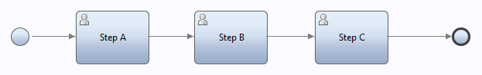
While working on a step, a user can say that something is "wrong" that will result in the process as a whole being restarted after some data changes. For example, in "Step B", a user could see something that invalidates the whole process. The user should then be able to press a button that would cause a task to be created that allows someone to modify the process instance data and then we begin again from "Step A".
One solution to this puzzle would look as follows:
在一个步骤中工作时,用户可以说某些东西是“错误的”,一然后些数据更改后将导致整个流程被重新启动。例如,在“步骤B”,用户可以看到流程的一些东西是无效的，那么用户应该能够按下一个按钮去创建一个任务,让别人修改流程实例数据,然后我们再从“步骤A”重新开始。
这个谜题的一种解决方案如下:

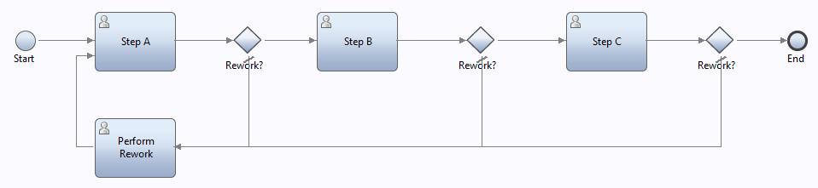
Here, after a Step completes, we now realize that it could complete because a rework was requested. After each step we then check if a rework was indeed requested and if it was, we then explicitly go and perform that rework. This is a good solution. It is very visible on the diagram.
在这里,一个步骤完成之后,我们现在意识到它因为要求返工才能完成，然后我们每一步检查是否有需要返工的请求,如果有,我们然后显式地去执行返工。这是一个很好的解决方案，在图上是很显而易见的。

Another solution would be to use the concept of exceptions. Now, when a rework is requested, the Step itself throws an exception which might be called "Rework". The diagram may now look like:
另一种解决方案是使用异常的概念。现在,当一个返工要求,步骤本身抛出一个异常,可能被称为“返工”，现在这个图可能看起来像:

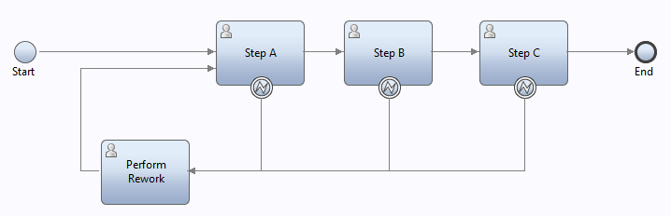
Here we are saying that we have an "expected" path and a rework request, although very valid, we call an exception. Within the logic of the Human Service that implements the step, we would now raise the exception:
我们说,我们有一个“预期”路径和返工要求,虽然很有效,我们称之为一个异常，我们在人工服务的逻辑里实现了这一步将这个异常抛出:
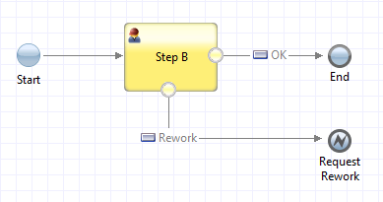
A third choice would be the use of the sub-process. We would have a top-level process that looks as follows:
第三个选择将使用子流程，我们将有一个顶级流程看起来如下:
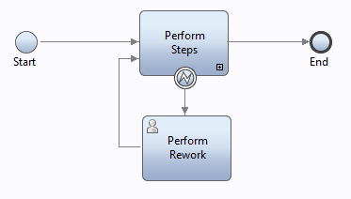
The Perform Steps activity is a sub-process that contains:
子流程里的每一步骤活动应当包含：
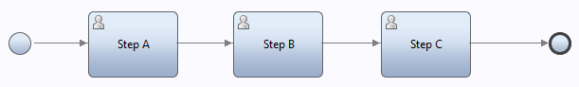
Each step can throw a Rework exception which is then caught by the container process.
All three of the techniques describes here are equally valid. Which one you choose is as much a matter of taste. The results should be identical. The choice used would be to the taste of the designer as to how best they comprehend the resulting diagrams so that they can be read and understood by others.
每一步可以抛出一个返工异常然后被父流程捕捉。
这里描述的所有三个技术具有同等效力。你选择哪一个是口味问题，结果应该是相同的。设计师的口味表明他们是如何理解结果图,这样他们也可以被他人解读和理解。

